Getting [Town Name] Flood Ready
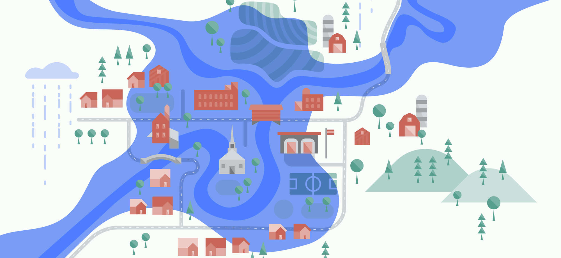Come to discuss opportunities to make our community safer.

[month day, year]
[time]
[location]

For more information and to RSVP contact:
[Name]
[phone]
[email]

