USING THE FLOOD READY ATLAS
THE FLOOD READY ATLAS shows all River Corridors and some special flood hazard areas (SFHA). If you don’t see the SFHA in your community, you’ll need to use the paper maps at your town offices or FEMA’s digital map service: bit.ly/fema-firm. If you don’t see a River Corridor for small streams, assume that the Corridor extends fifty feet from the top of each bank.

Follow these steps to use the Flood Atlas
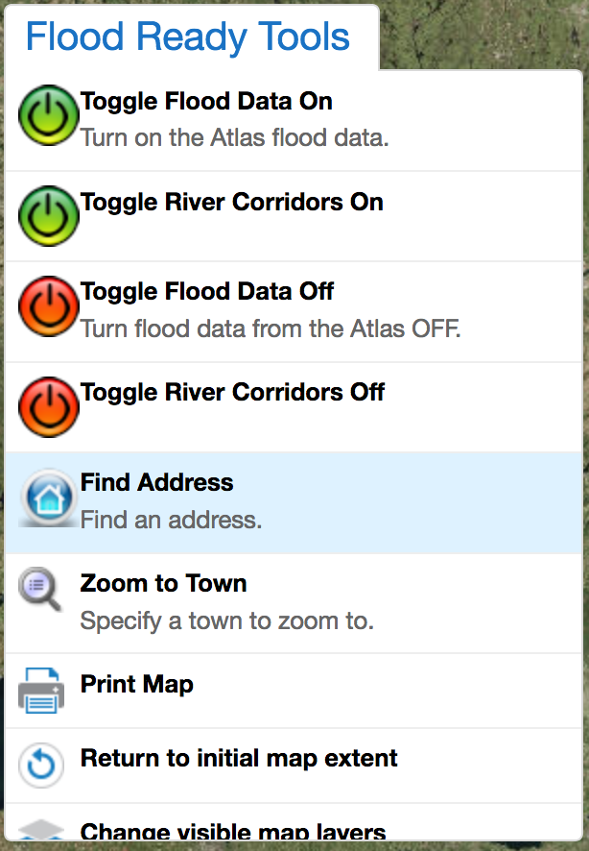
- Type bit.ly/floodatlas into the address bar of your web browser. A green and blue globe will appear as the map loads. This could take a minute. If the map won’t load after a few minutes, you may want to try a different browser.
- Click on Flood Ready Tools in the upper left corner of the map and Click on Find an Address in the dropdown menu.
- One or multiple results should appear. Click on the title for one of the results and a marker should appear on the map. Click on that result address that appeared in place of the title and the map will zoom to that location. You may use the + and - buttons in the upper left corner of the map to zoom further in or out. You may also click and drag the map to pan in a direction.
- Click on Flood Ready Tools in the upper left corner of the map again and click the Toggle Flood Data On. Repeat this step and click the Toggle River Corridors On link.
- Look for semi-transparent layers to appear on the map. If you don’t see any, there may not be any sizeable waterways and/or, you may not have SFHA mapped in the atlas yet for your location. You may click on the layers to identify what they are. In this example, the River Corridor is the light yellow layer following the river. The orange and red layers are the SFHA. The red area with the diagonal lines is the Floodway.
- There are several other data layers you can explore. Click on the Layers button on the lower left corner of the map to view them all. Check boxes to add or remove layers. Click the + icons to expand groups of layers.

