Reducing Flood Damage **in Our Community**

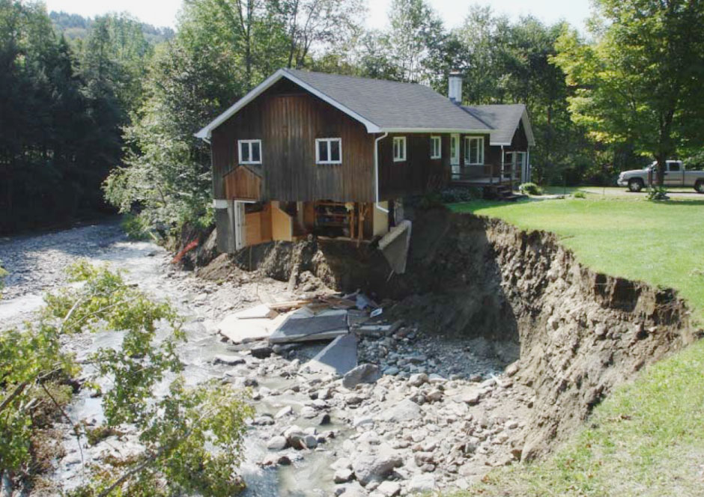

Our Town is updating our bylaws to reduce the risk of flood damage and expensive repairs to our roads.   
  
The new bylaws support building in safer places, in safer ways. They also qualify the Town for additional state funding after disasters (ERAF) and they ensure residents can purchase flood insurance through the National Flood Insurance Program (NFIP), which is required to get a mortgage on any home in the Special Flood Hazard Area (SFHA).

## What does the update include?

1. In the river corridor, don’t build closer to the river than existing buildings.
2. In the flood hazard area, the lowest floor of new buildings must be two feet above the expected level of a 100-year flood (which may come much more often than once a century).
3. In the flood hazard area, don’t add fill that would put others at risk.

Read the full model bylaws we are adapting for our use: <http://bit.ly/model-bylaw> [If you already have an adapted draft, replace the link with a link to your draft.]

## Why now?

The Town needs to update the bylaws before FEMA’s new Flood Insurance Rate Maps become effective.

Extreme storms are getting more frequent and we want to reduce the safety and financial risks they bring to our community.

## Process and opportunity to participate:

1. The Town Planning Commission drafts bylaw updates and holds a public hearing. **This drafting and hearing process is the best opportunity for the public to engage in the process**. The first public hearing is scheduled for [ADD DATE/TIME/LOCATION]
2. The Town Selectboard holds a public hearing.
3. The bylaw updates are adopted by the Select Board or by Australian ballot [CLARIFY FOR YOUR TOWN].
4. The final bylaws must be approved by FEMA to allow residents to continue purchasing flood insurance from the NFIP.

Follow Planning Commission meetings to track the process and provide your ideas. [ADD ADDITIONAL INFORMATION ABOUT HOW CITIZENS CAN BE INVOLVED]

## What and where are Special Flood Hazard Areas and river corridors?

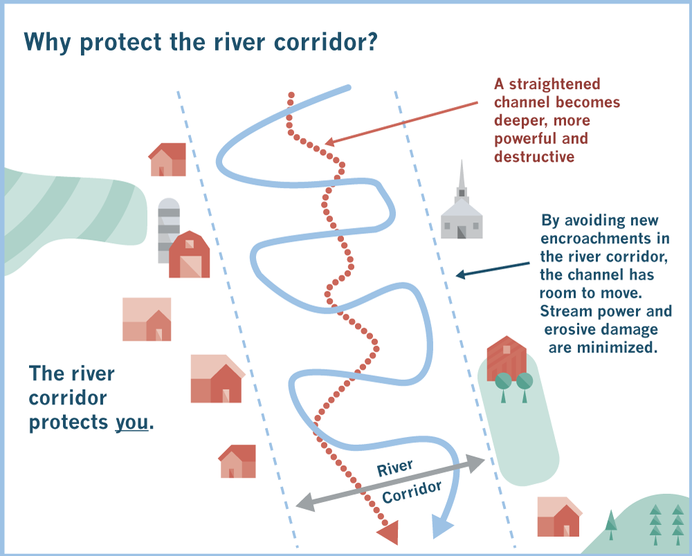

**River Corridors** identify the area near rivers and streams needed to allow the water channel to move over time. This avoids straightening and deepening the channel and allows floodwater to slow down and not increase flood levels and damage from erosion.

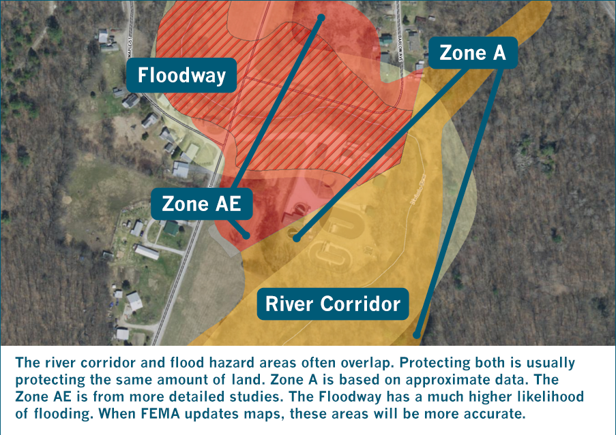

Learn more about the critical services our river corridors and floodplains provide for us at: https://bit.ly/flooding-concepts

The new SFHA and river corridors can be viewed: [PROVIDE LINKS TO SEE NEW MAPS or DELETE THIS LINE IF NOT YET AVAILABLE]

View the current SFHA on the FEMA website: <http://msc.fema.gov>

View River Corridors on the Flood Ready Atlas <http://bit.ly/floodatlas>

**Special Flood Hazard Areas** are areas that FEMA predicts have a 1% chance of flooding each year, based on flood gauge records and other studies. These areas have a one-in-four chance of flooding over a thirty-year mortgage.