New Bylaws for our Hazard Areas
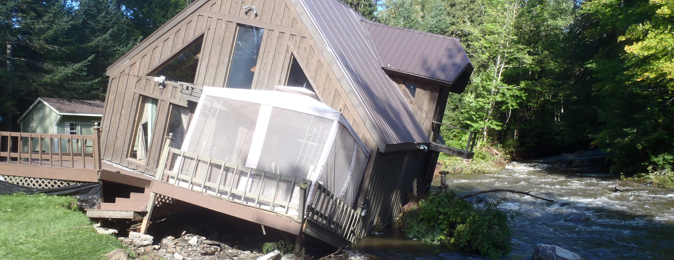
The [Town Name] Select Board has adopted [or is considering if this is in process] new rules for building in our flood and erosion hazard areas.
These rules:
- protect our neighbors, buildings, and roads;
- reduce the risk of a tax increase to repair damage; and,
- allow residents to purchase flood insurance.
[Consider a statement about how the new bylaws further the community vision and align with things people care about.]
To learn more:
- Read the new bylaw: [add link]
- Learn where flood hazard areas and river corridors are: bit.ly/flood-atlas
- For more information: [contact info]
- [If still in process of adoption, invite people to participate.]

